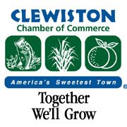
The Clewiston Chamber is hosting Candidate forums. You can click on the links below for more information.
August 4, Thursday at 10 AM
Candidate Forum School Board District 5
https://www.facebook.com/events/444552650866439

August 4, Thursday at 1 PM
Candidate Forum School Board District 4
https://www.facebook.com/events/1092254718376052

August 4, Thursday at 3 PM
Candidate Forum for Hospital Board District 4
https://www.facebook.com/events/1102119503991449

